Book

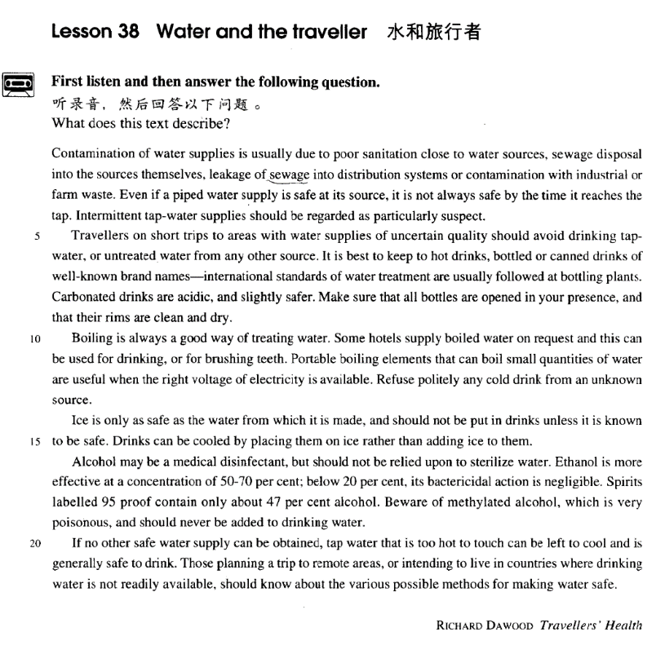

课文

Contamination of water supplies is usually due to poor sanitation close to water sources,

水源的污染通常是由于接近水源的地方卫条件太差而造成的：

sewage disposal into the sources themselves, leakage of sewage into distribution systems or contamination with industrial or farm waste.

污水排入水源，污水渗入给水系统或工农业污水造成污染。

Even if a piped water supply is safe at its source, it is not always safe by the time it reaches the tap.

即使管道供水系统在水源处安全的，等水到达龙头时就不一定总是安全的了。

Intermittent tap-water supplies should be regarded as particularly suspect.

断断续续的水管应该被视为是非常可疑的。

Travellers on short trips to areas with water supplies of uncertain quality should avoid drinking tap-water, or untreated water from any other source.

短途旅行到水质不保险的地区时，应避免饮用水龙头的水或未经处理任何其他来源的水。

It is best to keep to hot drinks, bottled or canned drinks of well-known brand names-international standard of water treatment are usually followed at bottling plants.

最好仅饮用开水，名牌瓶装或罐装水 -- 装瓶厂通常遵循国际水处理的标准。

Carbonated drinks are acidic, and slightly safer.

碳酸饮料是酸性的，就更安全一些。

Make sure that all bottles are opened in your presence, and that their rims are clean and dry.

确保瓶子是当你面开启的，瓶口清洁干燥。

Boiling is always a good way of treating water.

烧开一直是水处理的一种好办法。

Some hotels supply boiled water on request and this can be used for drinking, or for brushing teeth.

有的酒店根据要求可提供开水，这些开水可用于饮用和刷牙。

Portable boiling elements that can boil small quantities of water are useful when the right voltage of electricity is available.

如果有相配的电压，可以煮少量水的便携式热水装置是有用的。

Refuse politely any cold drink from an unknown source.

应谢绝任何不明来源的冷饮。

Ice is only as safe as the water from which it is made, and should not be put in drinks unless it is known to be safe.

冰块只有当制造冰块的水安全时才是保险的，只有知道冰块安全时才能加入饮料。

Drinks can be cooled by placing them on ice rather than adding ice to them.

可以把饮料置于冰块之上来冷却，而不是把冰块加进饮料之中。

Alcohol may be a medical disinfectant, but should not be relied upon to sterilize water.

酒精可能是医学上的消毒剂，但决不可用来消毒饮用水。

Ethanol is more effective at a concentration of 50-70%; below 20%, its bactericidal action is negligible. Spirits labelled 95 proof contain only about 47% alcohol.

乙醇的浓度为50%至70%时比较有效，浓度低于20%时，杀菌能力基本上就不存在了。

Beware of methylated alcohol, which is very poisonous and should never be added to drinking water. If no other safe water supply can be obtained, tap water that is too hot to touch can be left to cool and is generally safe to drink.

强度标为95的酒中含有47%的酒精。要提防甲基化酒精，那是剧毒的，永远不能掺入饮用水。

Those planning a trip to remote areas, or intending to live in countries where drinking water is not readily available, should know about the various possible methods for making water safe.

如果没有其他安全的饮用水，水管中流出的烫手的水可以留下来冷却。这种水一般是安全的。

词汇讲解

Lesson 38 Water and the traveller

contamination [kən7tæmɪ'neɪʃən]

n. 污染

contaminate v. to make a substance or place dirty or no longer pure by adding a substance that is dangerous or carries disease 污染

a river contaminated by chemicals

We continually wages war on them, for they contaminate our food, carry diseases, or devour our crops.

They were accused of contaminating the minds of our young people. Children are becoming contaminated by the prevailing cynicism of the age.

contaminant n. [C] (fml.) substance that contaminates things 污染物

contamination n. [U] contaminating or being contaminated 污染

radioactive contamination contamination of the water supply sanitation [7sæni'teiʃən]

n. 卫生系统或设备

sanitation n. [U] the protection of public health by removing and treating waste, dirty water etc. 卫生系统或设备

inadequate / poor sanitation

disease resulting from poor sanitation

Contamination of water supplies is usually due to poor sanitation close to water sources, …

Many illnesses in these temporary refugee camps are the result of inadequate sanitation.

sanitary adj. connected with keeping places clean and healthy to live in, especially by removing human waste = hygienic 清洁卫生的Overcrowding and poor sanitary conditions led to disease in the refugee camps.

The hut had no cooking or sanitary facilities. “san” = whole（健全的）

sane adj. 神智正常的；明智的

sanity n. 神智正常；明智

insane “in” = not adj. 精神失常的，疯狂的，愚蠢的

insanity n. 精神失常，疯狂，愚蠢sanitary adj. 清洁卫生的insanitary adj. 不卫生的

sanitation n. 卫生系统或设备

sanitarian n. 公共健康专家sanatorium “ium” = 场所 n. 疗养院sewage ['su:ɪdʒ]

n.（下水道里的）污水，污物

sewage n. [U] the mixture of waste from the human body and used water that is carried away from houses by pipes under the ground（下水道里的）污水，污物

sewage disposal / treatment

sewer n. [C] a pipe or passage under the ground that carries away waste material and used water from houses, factories etc. 下水道

drain n. 1. (Br. E.) [C] 下水道，地沟；2. (Am.E.) [C]（卫生间或水池

的）排水口

On his way to the sweet shop, he dropped his fifty pence and it bounced along the pavement and then disappeared down a drain.

George took off his jacket, rolled up his sleeves and pushed his right arm through the drain cover.

drainage n. [U] 排水

The city was even equipped with a drainage system, for a great many clay pipes were found beneath the narrow streets.

intermittent [7ɪntə'mɪtənt]

adj. 断续的，间歇的

intermittent adj. stopping and starting often over a period of time, but not regularly 断续的，间歇的

intermittent bursts of applause

intermittent flashes of light from a lighthouse “mit” / “miss” = send

intermit “inter” = between v. 暂停

intermittent adj. 断续的；间歇的intermission n. 暂停；幕间休息admit “ad” = to v. 准许进入；承认admission n. 准许进入；承认emit “e” = out v. 发射，发出emission n. 发射，发出

omit “o” / “ob” = away v. 省略，删除；忽略，疏忽

omission n. 省略，删除；忽略，疏忽permit “per” = through v. 允许permission n. 允许

submit “sub” = under v. 提交，上交；服从，屈服submission n. 提交，上交；服从，屈服submissive adj. 服从的，顺从的

transmit “trans” = across v. 传输，传染

transmission n. 传输，传染

remit “re” = back v. 赦免，宽恕；汇款

remission n. 赦免，宽恕

remittance n. 汇款

manumit “manu” = hand v. 解放（奴隶） manumission n.（奴隶的）解放disinfectant [7dɪsɪn'fektənt]

n. 消毒剂，杀菌剂

disinfectant n. a chemical or a cleaning product that destroys bacteria 消毒剂，杀菌剂

infect v. to give someone a disease 传染

infect sb. with sth.

He has been infected with HIV.

infection n. 1. [U] 传染；2. [C] 传染病

disinfect v. 杀菌，消毒

disinfect a wound / surgical instrument / hospital ward

infectious / contagious / communicable

be highly ~

~ diseases catching

a catching disease X

I hope his cold isn’t catching.√

bactericidal [bæk7tɪərɪ'saɪdl]

adj. 杀菌的

bactericidal adj. destroying bacteria 杀菌的

“cid” / “cis” = cut bactericidal adj. 杀菌的

concise “con” = together adj. 言简意赅的

concision n. 言简意赅

excise “ex” = out v. 切除；删除

excision n.切除；删除

incise “in” = into v. 切开；雕刻

incision n. 切开；切口

incisive adj. 敏锐的，有洞见的precise “pre” = before adj. 精确的precision n. 精确

patricide “patr” / “pater” = father n. 弑父matricide “matr” / “mater” = mather n. 弑母suicide “su” = self n. 自杀

suicidal adj. 自杀的

pesticide “pest” = 害虫 n. 杀虫剂，农药

herbicide “herb” = grass n. 除草剂

Contamination *of water supplies* is usually due to *poor sanitation close to*

*water sources*, *sewage disposal into the sources themselves*, *leakage of*

*sewage into distribution systems* or *contamination with industrial or farm*

*waste*.

leakage n. [U and C] when gas, water etc. leaks in or out, or the amount of it that has leaked 泄露

As administrative overheads rise, so the earnings of the business after

meeting the expense of administration, will fall; and the business will have less money to distribute as dividends or invest directly in its future progress and development.

distribution system n. 配水系统，配水管网 ；配电系统

with prep. because of 因为She was shivering with cold. My hands are rough with work.

Anna was scarcely able to stand with exhaustion.

waste n. [U] unwanted materials or substances that are left after you have used something 垃圾，废料

household / industrial / chemical waste

Even if a piped water supply is safe at its source, it is not always safe *by the time it reaches the tap*.

pipe v. to send a liquid or gas through a pipe to another place 用管道输

送

villages with no piped water

Eighty per cent of sewage is piped directly into the sea.

… by the time when / that / at which it reaches the tap.

Intermittent tap-water supplies should be regarded as *particularly*

*suspect*.

…, or the sheriff made suspect by vicious gossip; …

Travellers *on short trips to areas with water supplies of uncertain quality*

should avoid drinking tap-water, or untreated water *from any other*

*source*.

of … quality

goods of the highest quality

Much of the land was of poor quality. The photos are of variable quality.

untreated adj. 1. describes a substance that is not cleaned and has not had special substances added to protect it or make it safe to use 未处理的untreated water / sewage / waste

untreated adj. 2. not receiving medical treatment 未治疗的

untreated illness / disease / depression

This condition may become permanent if left untreated.

It is best to keep to hot drinks, bottled or canned drinks of well-known

brand names ― *international standards of water treatment are usually followed at bottling plants*.

it is best (= It is wise) to do sth. It's best to go by bus.

It's best to go later in the season.

It's best to get to the supermarket early.

keep to = stick to 坚持，遵守，不放弃，不偏离

Keep to the speed limits.

It's best to keep to the track―the land is very boggy around here. bottled adj. sold in a bottle 瓶装售卖的

bottled beer / water

canned adj. (Br.E .also tinned) (of food) preserved in a can 罐装的

canned food / soup

brand name n. [C] the name given to a product by the company that makes it = trade name 商标名称

The EU should set minimum standards *of* employee rights.

We aim to maintain high standards *of* customer care. follow … standard(s)

have / boast / enjoy … standard(s) define / establish / set … standard(s) achieve / meet / reach … standard(s) fall short of … standard(s)

raise / lower … standard(s) maintain / sustain … standard(s)

bottling plant: a plant where beverages are put into bottles with caps（饮料）灌瓶厂

Carbonated drinks are acidic, and slightly safer.

carbonated adj. (of a drink) containing small bubbles of carbon dioxide

含二氧化碳的，起泡的carbonated drinks carbonated mineral water

carbonate v. to charge (a beverage, for example) with carbon dioxide gas

给（例如饮料）充二氧化碳气体

carbon n. 碳

carbon dioxide 二氧化碳carbon monoxide 一氧化碳acidic adj. contain acid 酸性的acidic soil

Dissolved carbon dioxide makes the water more acidic.

Make sure that all bottles are opened in your presence, and that their rims are clean and dry.

presence n. [U] being present in a place 出席，在场

We enjoy staring at them entranced as they go about their business, unaware (we hope) of our presence.

Everything around him was full of her presence, continually reopening the wound.

in sb.’s presence

in the presence of sb.

She asked them not to discuss the matter in her presence. The document was signed in the presence of two witnesses. absence n. being away 缺席，不在场

His frequent and prolonged absences were making his wife suspicious.

in / during sb.’s absence

in / during the absence of sb.

It was as clear as daylight then that burglars had forced an entry during her absence.

In the absence of any evidence, the police had to let Myers go.

As the heads of next-generation start-ups, these Asian innovators can draw on customs and languages to forge righter links with crucial Pacific Rim markets.

Boiling is always a good way of treating water. way of doing sth.

Is there any way of contacting you while you're in Africa? way to do sth.

What's the best way to learn a language?

Some hotels supply boiled water *on request* and this can be used *for*

*drinking*, or *for brushing teeth*. boiling water n. 滚开的水

boiled water n. 开水

on request: when asked for 一经要求

Further details will be sent on request.

at sb.’s request / at the request of sb. because of sb.’s wish 应某人之请求

I came at your request.

The study was done at the request of the Chairman. use sth. for (doing) sth.

They were using animals for scientific experiments. Bob uses the van for picking up groceries.

use sth. as sth.

May I use your name as a reference? use sth. to do sth.

Most people now use their cars to go shopping.

Portable boiling elements that can boil small quantities of water are useful *when the right voltage of electricity is available*.

portable adj. able to be carried or moved easily 便携式的

a portable radio / computer

portability n. [U] 便携性

The advantage of the smaller model is its greater portability.

element n. [C] part of an electric kettle, etc. that gives out heat 电 阻 丝

（电壶等供热的部分）

boiling elements

Refuse politely any cold drink *from an unknown source*.

Ice is only as safe as the water from which it is made, and should not be put in drinks *unless it is known to be safe*.

know … to do sth.

We know her to be honest.

What the child cannot forgive is the parents’ refusal to admit these charges if the child knows them to be true.

be known to do sth.

Two women are known to have died.

Smoking is known to increase a person's risk of developing lung cancer. Drinks can be cooled by placing them on ice *rather than adding ice to*

*them*.

rather than 常译为“而不是”，其词性比较灵活，在后面跟动名词短语时，一般视为介词。

She was angry rather than *being* pleased.

We ought to check up, rather than just *accepting* what he says.

rather than 后不加动名词时一般将其视为“准并列连词”，用于连接词性相同的词项。

She *telephoned* rather than *wrote*. *John* ought to go rather than *Jean*.

He is *to be pitied* rather than *to be disliked*.

I’m going to *forget* the whole affair, rather than *cause* trouble.

Alcohol may be a medical disinfectant, but should not be relied upon *to*

*sterilize water*.

alcohol n. 1. [U] the colorless liquid that is found in drinks such as beer, wine, etc. and is used in medicines, cleaning products, etc. = ethanol 酒精，乙醇

Wine usually contains about 10% alcohol.

levels of alcohol in the blood

Choose an alcohol-free skin toner if you have dry skin. alcohol n. 2. [U] drinks containing this 含酒精的饮料，酒prohibit the sale of alcohol.

I never touch alcohol.

For many young people drinking alcohol is a sign of 'growing up'. sterilize v. 1. to make sth. completely clean by killing any bacteria in it 消毒

Sterilize the bottles with boiling water.

sterilized milk

sterilize v. 2. if a person or animal is sterilized, they have an operation to stop them producing babies 使绝育

My wife was sterilized after the birth of her fourth child.

Ethanol is more effective at a concentration of 50-70 per cent; below 20 per cent, its bactericidal action is negligible.

concentration n. [C] the amount of a substance contained in a liquid 浓度

allowable concentrations of pesticides in drinking water

High concentrations of toxic elements were found in the polluted areas of the sea.

bactericidal action 杀菌作用，杀菌效果

action n. the effect that a substance, esp. a chemical, has on sth. 作用，效果，影响

the action of … on …

the action of alcohol on the liver

the action of certain chemicals on the brain

negligible adj. of very little importance or size and not worth considering

= insignificant 微不足道的

a negligible amount The cost was negligible.

Spirits *labelled 95 proof* contain only about 47 per cent alcohol.

spirit n. [C usually plural] a strong alcoholic drink such as whisky or brandy 烈性酒

I don't drink spirits.

Whisky, brandy and rum are all spirits.

label v. to attach a label onto sth. or write information on sth. 给（某事物） 加标签或标记

The file was labelled ‘Top Secret’.

proof n. a measurement of the strength of some types of alcoholic drink, esp. spirits 酒的度数

(Br.E.) 70% proof vodka ( = that contains 70% pure alcohol)

(Am.E.) 70 proof vodka ( = that contains 35% pure alcohol)

Beware of methylated alcohol, which is very poisonous, and should never be added to drinking water.

beware adj. (used only in the infinitive and imperative 仅用于不定式及

祈使句) used to warn someone to be careful because sth. is dangerous 当心，提防

beware of (doing) sth.

Motorists have been warned to beware of icy roads.

Beware of saying anything that might reveal where you live.

If no other safe supply can be obtained, tap water that is too hot to touch can be left to cool and is generally safe to drink.

leave sth. to do sth.

Leave the rice to cook for 20 minutes.

Those planning a trip to remote areas, or intending to live in countries

where drinking water is not readily available, should know about the various possible methods *for making water safe*.

remote adj. far from towns or other places where people live = isolated

偏远的，与世隔绝的

a remote border town

We always assume that villagers in remote places are friendly and hospitable.

easily / readily available / obtainable

Parking is readily available near the station entrance. The information is easily available on the Internet.

The Moon is likely to become the industrial hub of the Solar System, supplying the rocket fuels for its ships, easily obtainable from the lunar rocks in the form of liquid oxygen.

knows about sth.: If you know about a subject, you have studied it or taken an interest in it, and understand part or all of it. 对于……熟悉，通晓，懂行

I have a friend who knows about antiques.

Hire someone with experience, someone who knows about real estate. method for / of (doing) sth.

effective methods for the storage and retrieval of information Vaccination is one of the most effective methods for preventing disease.

There is no quicker method of disposing of patients than by giving them what they are asking for, …

Apart from moral considerations this is a stupid method of training, …